Reading Passage

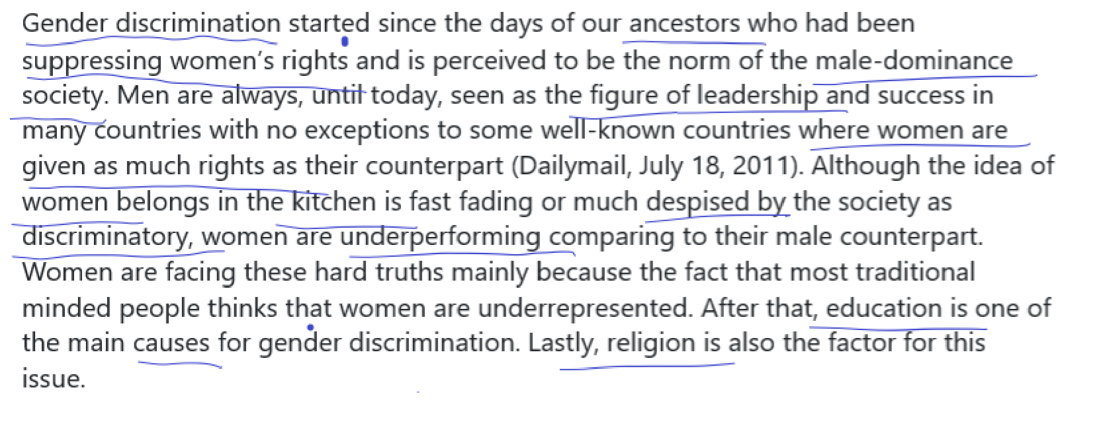

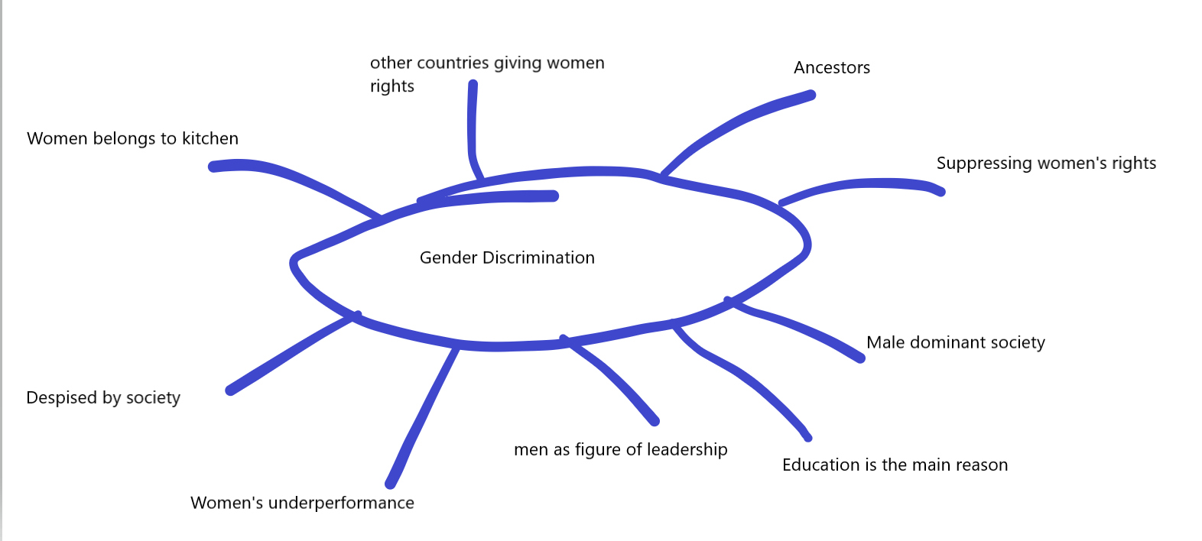

**Linkers**

And

Such as

As well as

However

Therefore

Moreover

For example

------------------------------------

From the time of our ancestors gender discrimination in our society has prevailed because the norms and practices of the culture portray men as the figure of leadership, dominating the society on the hand the same culture represents women as underperforming, as only belonging to kitchen and their rights are suppressed and they themselves are despised by the society however this mean attitude towards women prevails in the society because of lack of good education.

----------------------------------------------------------------------